Course Name | ITD 2313 – Script Programming
Instructor | Prof. Greg Morris
Student Name | Dean Ramsey
Due date | 10/26/2025
Grade | Put grade earned here
Grading Comments | Put instructor comments here

Week 8 - Scripting Projects Assignment
Page163 – 164:

Project # 3:
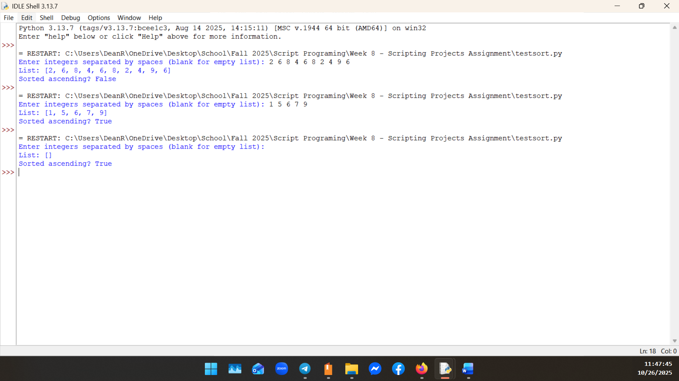
Project #7:
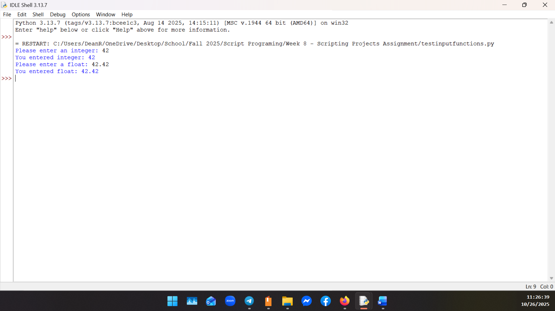

Page 187:
Project #6:
